The Acceptance Devices app sends an API response to the POS system with the transaction result and details. This completes the transaction.
Here are some troubleshooting steps for connection errors between PAX and POS:
- Verify payment settings
- Verify the IP address
- Verify the PAX communications parameters
- Ping test
- Run a sample sale
To check the current IP address lease for a PAX device, you can:
- Go to the Communications Menu
- Press the down arrow
- Select LAN Parameters
- Select the IP Address button
This will show the current IP address of the device on the network.
To restart a PAX device, you can:
- Unplug the power cable
- Wait 30 seconds
- Plug the power cable back in
To factory reset a PAX S300, you can:
- Press the Menu button on the device
- Select Maintenance from the list of options
- Select Factory Reset from the Maintenance menu
- Confirm that you want to proceed

Transaction Workflow for the PAX Semi-Integrated Solution
This is the transaction workflow for the PAX Semi-Integrated Solution.
https://developer.cybersource.com/docs/cybs/en-us/sis-pax/integration/all/rest/sis-pax/semi-integrated-solution-pax-workflow.html#:~:text=The%20Acceptance%20Devices%20app%20user,details%2C%20which%20completes%20the%20transaction.

Figure: 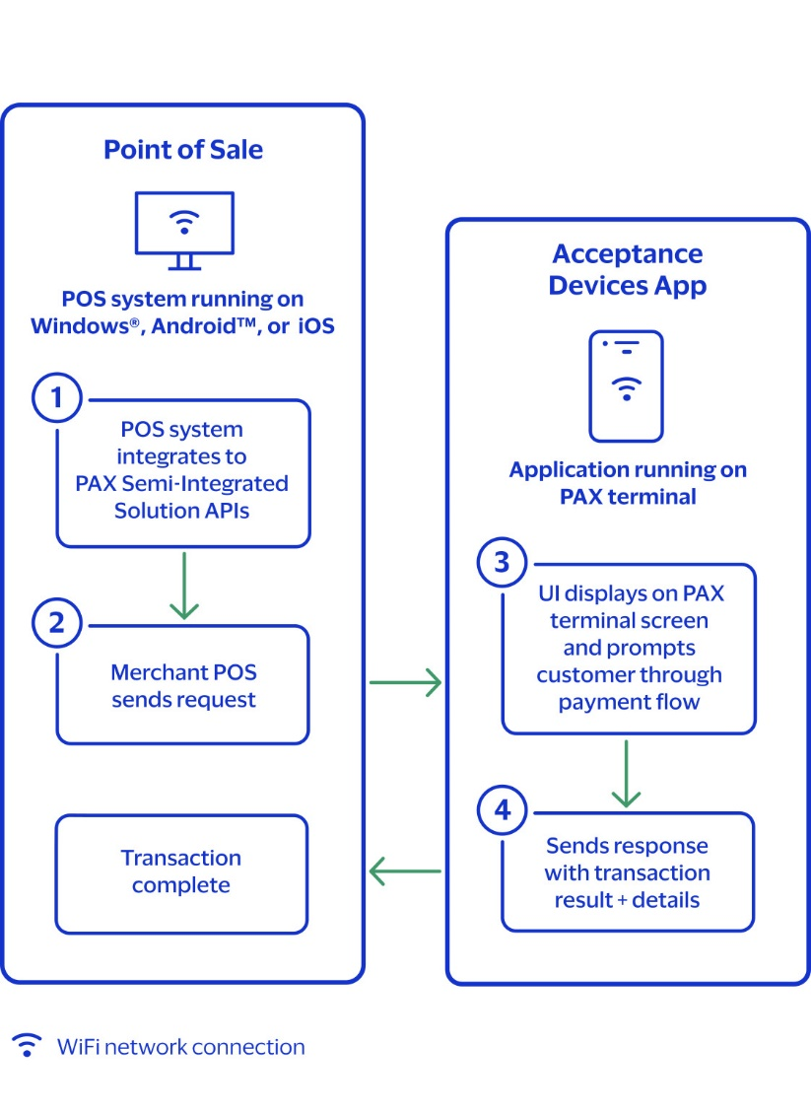
PAX Semi-Integrated Solution Transaction Workflow

- The point-of-sale (POS) system, running on Windows, Android, or iOS, integrates to the PAX Semi-Integrated Solution APIs.
- The merchant's POS system sends an API request to the Acceptance Devices app that is running on the PAX terminal.
- The Acceptance Devices app user interface displays on the PAX terminal screen and displays prompts to guide the customer through the payment flow.
- The Acceptance Devices app sends an API response to the POS system with the transaction result and details, which completes the transaction.

How to Troubleshoot Connection Error between PAX and POS?

https://retailcloud.gitbook.io/hardware/payment-devices/pax-s300/common-issues/how-to-troubleshoot-connection-error-between-pax-and-pos
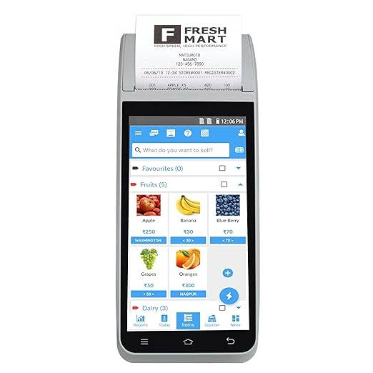

A mobile POS (mPOS) system is a portable point of sale that uses a smartphone or tablet as a register. It can accept credit cards and contactless payments.

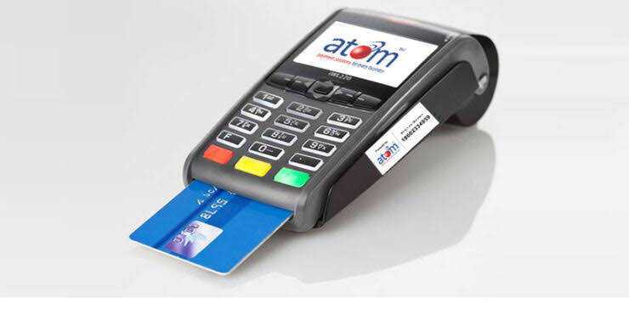

A card swipe POS machine, also known as a payment terminal, is a portable device that helps businesses process payments using credit or debit cards.

